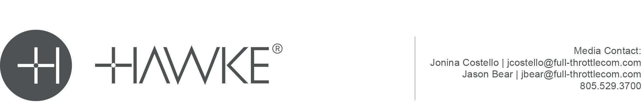

HAWKE® OPTICS INTRODUCES NEW XB30 CROSSBOW SCOPE

Hawke Didn’t Invent Crossbow Scopes… They Perfected Them… Again!

Hawke® Optics, a worldwide leader in quality sporting optics that perform outstanding in the field while maintaining optimum value for the consumer, adds to their premier line of crossbow scopes with a new model. The addition of the XB30 2-7x32 solidifies Hawke as the leader in clear, precise, and durable crossbow scopes. Hawke’s crossbow scopes are designed to withstand the rigors of crossbows with reticle and turret systems guaranteed to make you a better shot!

The new XB30, along with all other XB30 and XB models, feature our vari-speed technology, allowing any bow to be dialed in to create unsurpassed accuracy. The highly desired locking speed adjuster ring ensuring the FPS setting is not changed once zeroed is also a key feature of the new XB30. Hawke’s XB30 2-7x32 also features a multi-line reticle with aim points out to 100 yards, incorporating windage bars. Coming alongside their best-selling models, this new for 2023 model enhances Hawke’s most desired crossbow scope features. Some of these features include 5 levels of brightness with red and green illumination, a locking speed selector ring, a wide-angle field of view, and a yardage-etched reticle design.

Built on the foundation of our best-selling crossbow scope, the all new XB30 2-7x32 combines our best features into one. This new model is optimized for today’s modern crossbows. Highlighting Hawke’s patented locking speed adjustor ring to prevent accidental adjustment of your zero and a clean, yardage-etched reticle design, the addition of this XB30 showcases Hawke’s stronghold lead on the crossbow scope market. With ½ MOA low-profile fingertip turrets for easy adjustments, 11 layers of fully multi-coated lenses to provide maximum clarity and built on a 30mm mono-tube chassis for superior strength, the new XB30 is a must for your next hunt!

A new and simplified version of the ever-popular XB reticle gives crossbow hunters and target shooters a clearer view to optimize every scenario, where every second counts. The laser-etched reticle features aimpoints from 20 to 100 yards and can be calibrated to bow speeds from 280 to 440 fps.

As with all of Hawke’s scopes, the new XB30 2-7x32 is water, shock, and fog proof and nitrogen purged. This feature packed model, with an everyday MSRP of $249, also has a fast focus eyebell and a generous 4-inch eye relief. Add their No-Fault Lifetime Warranty and you can’t beat it! Hawke didn’t invent crossbow scopes… they perfected them… again!

About Hawke
#VISIONACCOMPLISHED. Hawke is a worldwide market leader at the forefront of optical performance with class-leading innovation and design offering a complete line of sport optics from rifle, crossbow, shotgun and air gun scopes to binoculars, spotting scopes and accessories. Accuracy, strength, and precision; Hawke optics blend iconic design, exceptional engineering, and unrivalled craftsmanship to create an unforgettable viewing experience. As awareness of Hawke Sport Optics continues to grow, more customers are trusting Hawke as the unquestioned industry leader in optics. Learn more at www.hawkeoptics.com.

Follow the #Hawkelife lifestyle hub and connect with us on social media:

Editor’s Note: For downloadable hi-res images and press releases, visit our online Press Room at www.full-throttlecommunications.com

